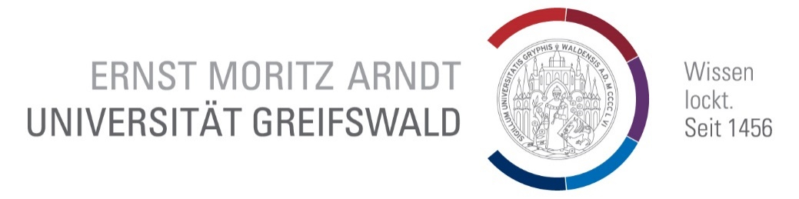
APPLICATION FORM ERASMUS+
Institute for Political and Communication Science

Basic Information
Last name | First name
Address | Email

Planned Mobility
Department | Wählen Sie ein Element aus.
In which program are you currently enrolled? | Wählen Sie ein Element aus.
Which term are you currently studying? | Wählen Sie ein Element aus.
How many semesters do you want to spend abroad? | Wählen Sie ein Element aus.
Which term do you want to spend abroad? | Wählen Sie ein Element aus.
☐ Winter term 20__
☐ Summer term 20__
Please indicate three universities you would want to visit in decreasing priority:

Self-Assessment Language Skills
Please indicate the level of proficiency of up to three languages?
Wählen Sie ein Element aus.
Wählen Sie ein Element aus.
Wählen Sie ein Element aus.

Motivation and Expectation “Knowledge & Skills“
Please describe your motivation and expectation regarding your stay abroad. What kind of knowledge do you want to acquire? What kind of skills/skill set do you expect to gain? Why is the university you have given first priority to especially suited to achieve your aims?

Motivation und Expectation “Soft Skills“
Please describe your motivation and expectation regarding those “soft skills” you expect to acquire. What kind of skills/skill set do you expect to gain? Why is the university/town/country you would like to visit especially suited to achieve those aims?

Past Commitments
Please describe any social activities you were committed to in the past, such as sports coach, leader of youth groups, and the like.

Visit https://europass.cedefop.europa.eu/resources/european-language-levels-cefr for the corresponding „Self Assessment Grid“.

